CSC8004 - Network Coursework

Terms

U = set-up time for circuit switch (seconds)

Y = transmission delay per link (seconds) (also called “transfer delay”)

L = message length (bits) >0

R = transmission rate (bits per second) >0 (also called “placement rate”)

H = header size (bits) =>0

P = packet size (bits) >H (note that this is the total packet size, i.e. header + data)

X = decision time per packet (also called “packet routing delay”)

1.

When the decision time per packet is 0.5 seconds

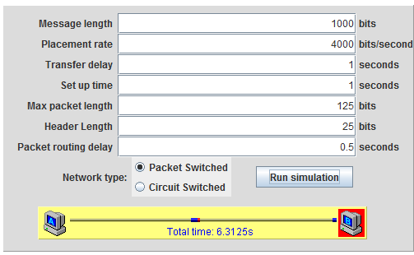

The equation for a packet switch network on a tandem topology is -

Time = (N*X) + (L+ (N*H))/R+Y

Time = (10*0.5) + (1000+ (10*25))/4000+1

* A packet switched network take 6.3125 seconds to transmit the message

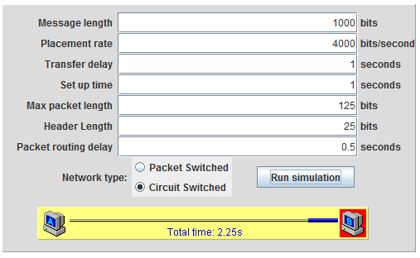

The equation for the circuit switch network on a tandem topology is -

Time = U+ (L/R) +Y

Time = 1+ (1000/4000) +1

* A circuit switch network takes 2.25 seconds to transmit the message

2.

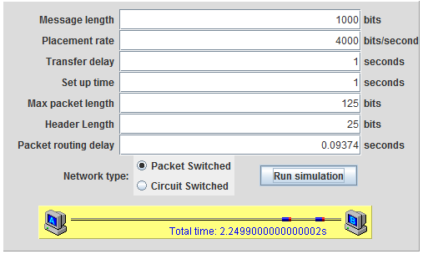

To work out which value of X the packet switching network is quicker than the circuit switch network, we can first use the following equation to make the transfer time equal.

U+ (L/R) +Y = NX + (L+NH)/R+Y

The first part of the equation (U+ (L/R) +Y) is the transmission time over a circuit switch network, and as in the previous question equals 2.25. The second part is to work out the packet switch transmission time and what value of X would make it equal. The following steps are used to equate this.

2.25 = (10*X) + (1000+ (10*25))/4000+1

2.25 = (10*X) +1.3125

0.225 = (X) +0.13125

0.225-0.13125 = 0.09375

With this configuration the transmissions times are equal when the packet switched network decision time is 0.09375.

* A packet switching network is therefore faster at 0.09374 seconds.

3.

The decision time per packet is set at **0.09375.**

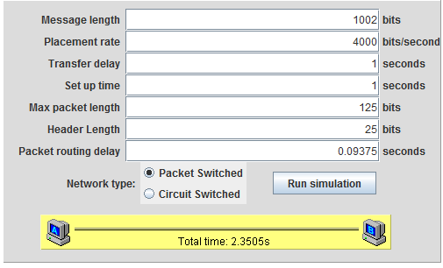

For the packet switch network, an additional packet is required to transmit the data, meaning 11 packets are now required.

Time = (N*X) + (L+ (N*H))/R+Y

Time = (11*0.09375) + (1002+ (11*25))/4000+1

* A packet switched network take 2.3505 seconds to transmit the 1002 bit message, 0.1005 seconds longer than with 1000 bits.

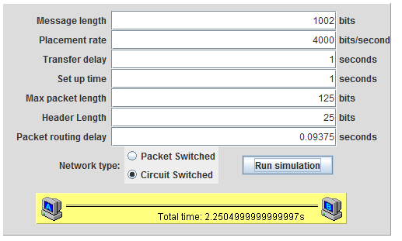

For the circuit switch network there is no added overhead cost, only the cost of sending the 2 extra bits.

Time = U+ (L/R) +Y

Time = 1+ (1002/4000) +1

* A circuit switch network takes 2.2505 seconds to transmit the 1002 bit message, an extra 0.0005 seconds than with 1000 bits.

The packet switch network takes 0.1 seconds longer to transmit the message than the circuit switch network. The reason for the additional 0.1 seconds is that an additional packet results in extra decision time per packet cost (0.09375 seconds) and an extra 25 bits of data to be sent as a header for the new packet.

The time cost of sending an extra 25 bits of data is L/R (25/4000 = 0.00625).

* Thus the additional 0.1 seconds taken is because of 0.09375 seconds of decision time per packet, plus 0.00625 seconds of additional transmission time for the header (0.09375+0.00625 = 0.1 seconds).

4.

With the message length at 1004 bits for the packet switch network 11 packets are required.

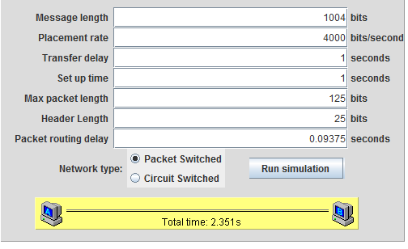

Time = (11*0.09375) + (1004+ (11*25))/4000+1

* A packet switched network take 2.351 seconds to transmit the 1004 bit message, 0.0005 seconds longer than transmitting 1002 bits.

For the circuit switch network

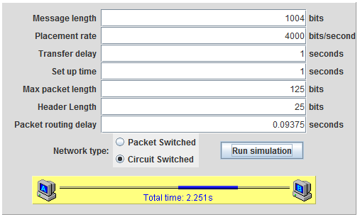

Time = 1+ (1004/4000) +1

* A circuit switch network takes 2.251 seconds to transmit the message, 0.0005 seconds longer than transmitting 1002 bits.

There are no additional overhead time costs for either network; no new packets need to be created or new circuits to set up.

* Therefore the only time cost is the additional 2 bits of data to be sent, equated (L/R – 2/4000 = 0.0005 seconds) and this is why the additional time for both networks is equal.

5.

X set at 0.09375.

When transferring over a star network with a packet switch circuit, all originating nodes can send packets simultaneously to node G, however node G can only send one packet at a time to its receiving node. Therefore packets can be queued at node G.

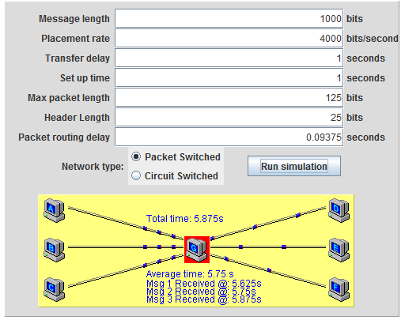

When transferring A-D, B-E and C-F, to calculate how long it takes for the first packets to arrive at Node G this equation is used –

X + (P/R) + Y

0.09375 + (125/4000) + 1 = 1.125

The packets will then begin to queue at Node G whilst it send each packet individually to its receiving node. To calculate how long it takes for all the packets from each message (3 nodes, N = 10) to be sent this equation is used –

3N (X+ (P/R)) +Y

30 * (0.09375+ (125/4000)) +1 = 4.75

These 2 figures are then added to give the total time for the completed messages to be received.

Time = (X + (P/R) + Y) + (3N (X+ (P/R)) + Y

Time = 1.125 + 4.75 = 5.875

* A packet switched network take 5.875 seconds to transmit all the messages

The final packets from each message will be packets 28, 29 and 30. On this simulator packet 28 is being sent with L1, packet 29 with L2 and packet 30 with L3.

L1 completes when the 28th packet has been received. To calculate the total time, 2 packets are subtracted from (3N (X+ (P/R)) – 1)

((0.09375 + (125/4000) + 1)) + (((3*10)-2) * (0.09375+ (125/4000)) + 1

* On a packet switch network L1 completes after 5.625 Seconds

L2 completes when the 29th packet has been received. To calculate the total time, 1 packet is subtracted from (3N (X+ (P/R)) – 2)

((0.09375 + (125/4000) + 1)) + (((3*10)-1) * (0.09375+ (125/4000)) + 1

* On a packet switch network L2 completes after 5.75 Seconds

L3 completes when the 30th and final packet has been received.

((0.09375 + (125/4000) + 1)) + (((3*10)) * (0.09375+ (125/4000)) + 1

* On a packet switch network L3 completes after 5.875 Seconds

The difference between each message is 0.125 seconds. This is

X+ (P/R)

0.09375+ (125/4000) = 0.125 seconds

When transferring over a star network with a circuit switch, only one node can send a message at a time, and the line is locked until the message is complete. The equation is now (Time = U+ (L/R) +Y+Y), the extra Y is because there is an extra node thus an extra transfer delay. As there are 3 messages, this is then multiplied by 3 for the total time. Therefore in this circuit switch network –

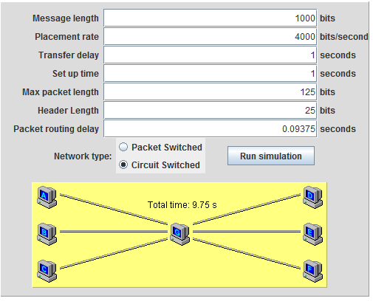

Time = U+ (L/R) +Y+Y

Time = 1+ (1000/4000) +1+1

* A circuit switch network takes 3.25 seconds to transmit each individual message, with a total transfer time of 9.75 seconds
* L1 takes 3.25 seconds to send
* L2 begins sending after L1. It takes 3.25 seconds and completes at 6.50 seconds total transmission time.
* L3 begins sending after L2. It takes 3.25 seconds and completes at 9.75 seconds total transmission time.

6.

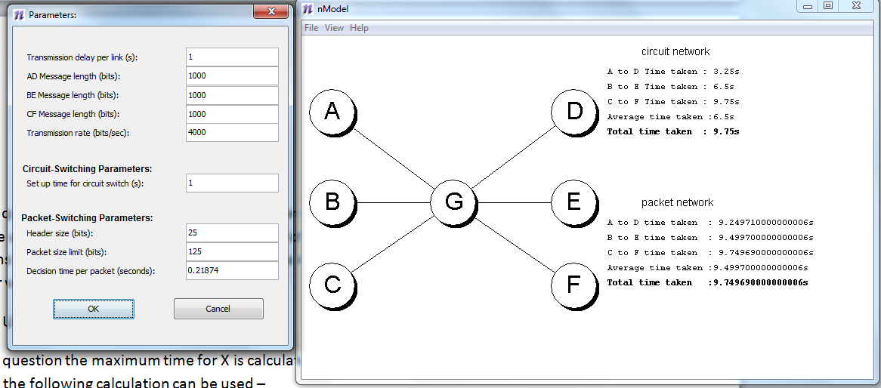

As with question 2, to work out at which rate the packet switching network is faster the following equation can be used to first get the transmission times equal to the circuit switch time of 9.75 –

Packet time = (X + (P/R) + Y) + (3N (X + (P/R)) + Y

9.75 = ((X + (125/4000) + 1)) + ((3 * 10) * (X+ (125/4000)) + 1

9.75 = (X + 0.03125+1) + (30 * (X + (0.03125)) + 1

9.75= X + 1.03125 + (30 * (X + (0.03125))) + 1

9.75= X + 1.03125 + (30 * X) + (30 * 0.03125) +1

9.75= X + 1.03125 + (30 * X) + 1.9375

9.75= X + (30 * X) + 2.96875

9.75-2.96875 = 31X

6.78125 = 31X

0.21875 = X

Therefore with the decision time per packet at 0.21875 seconds the two networks are equal.

* At 0.21874 the packet switching network is faster.

7.

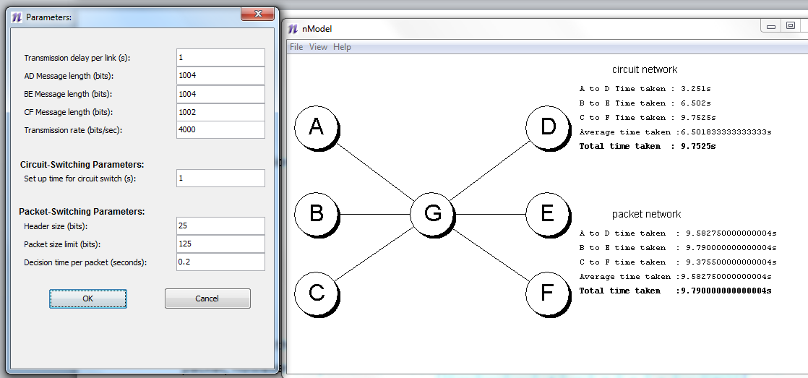

The transmission times for this configuration on a packet switch network are

L1 – 9.58275 seconds

L2 – 9.79000 seconds

L3 – 9.37550 seconds

All messages have 11 packets. The final packets for L1 and L2 are 29 bits (25 bits for the header, 4 bits for the message). For L3 the final packet size is 27 bits (25 bits for the header, 2 bits for the message).

The 11th packets are sent by each originating node at the same time. L3 (C to F) has the smallest transmission time for this packet as it has the smallest amount of data. Its final packet arrives in full first at node G, and is therefore it is the first of the final packets to be sent on to its receiving node. The packets from L1 and L2 queue at node G until the packet from L3 has been sent. The difference in transmission time for the extra 2 bits of data is L/R -

2/4000 = 0.0005 seconds extra for L1 and L2 to transmit.

* L3’s transmission time is the shortest as it has an equal amount of packets to the other messages but the least amount of data in the final packet. Its 11th packet is therefore fully received first by node G and first forwarded to its receiving node.

8.

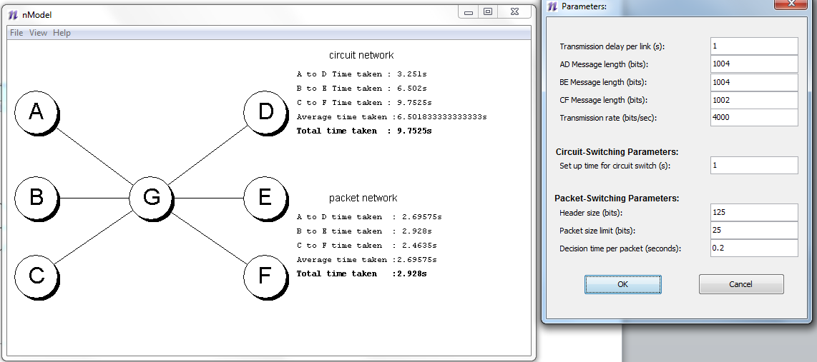

The total transmission time for all 3 messages to be received is 9.7525 seconds. The length of time each individual message takes to transmit are -

L1 – 3.251 seconds

L2 –3.251 seconds (completes at 6.502 of the transmission time)

L3 –3.2505 seconds (completes at 9.7525 of the transmission time)

Only one node can send at a time over a circuit switch network, and in this simulator L1 first locks the line, meaning its message is received first of the three messages. The line is then released and L2 sends, then finally L3.

L1 and L2 have identical individual transmission times because all figures in the equation (U+ (L/R) +Y+Y) are identical.

1+ (1004/4000) +1+1 = 3.251

L1 and L2 = 3.251 seconds

In L3 there are 2 bits less in the message (L/R - 2/4000 = 0.0005 second) which means L3 is faster to transmit and individually the fastest message to transmit across the network.

1+ (1002/4000) +1+1 = 3.2505 seconds

L3 = 3.2505 seconds

* The message L1 arrives at its receiving node first and hence has the shortest overall time to transmit, 3.251 seconds after the nodes start sending.
* The quickest individual message of the three is L3, sent from 6.502 to 9.7525 seconds. This only takes 3.2505 seconds as there are 2 bits less data to send.